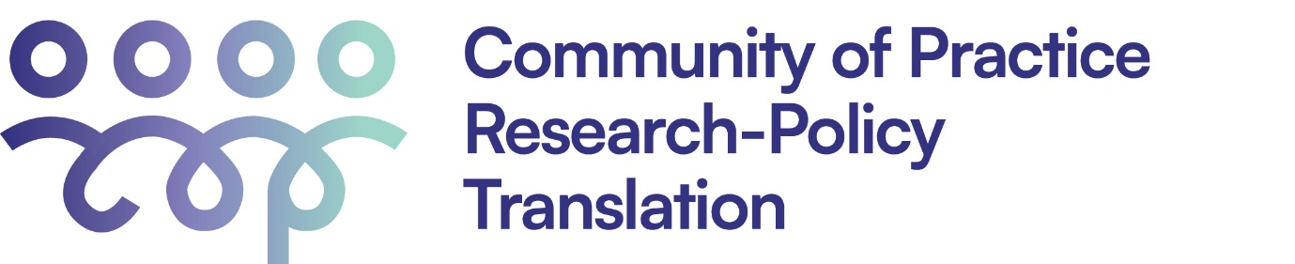

Research-Policy-Practice Translation Community of Practice
Workshop November 2025

‘Translating research for local impact’

Introduction:
The vision of the Research-Policy Translation Community of Practice (RPT CoP) is for timely and effective translation of research into policy and practice to become embedded into public policy processes across sectors and disciplines. This will support holistic evidence-informed, efficient, and collaborative approaches to societal challenges.
This RPT CoP workshop is the seventh in the series aiming to forge and foster interdisciplinary relationships and collaboration, as well as research-policy-practice translation capacity and capability development among CoP participants.
This workshop will be jointly facilitated Yonatal Tefera and Carmel Williams of CHiAPRT.

COP Objectives:
- To support research-policy-practice translation capacity development through workshops and the establishment of a resource repository
- To promote interaction among individuals, teams, and organisations from a diverse range of sectors and disciplines, to support cross-sectoral collaboration
- To facilitate information sharing and communication between researchers, policy actors and practitioners
- To advocate for more effective research-policy-practice translation practices

Event details:
Date: Wednesday 19th November 2025
Time: 3:00pm to 5:00pm
Venue: Rundle Mall Plaza, Meeting Room 5

Event format:
3.00pm Welcome and Acknowledgement of Country
Introductions, welcomes, housekeeping, overview of session
3.10pm Icebreaker and networking time
3.30pm Group photo
3:40pm Introduction to ‘FAME: Economics of Trees’ project by Yonatal Tefera
3:55pm Discussion with the project team, facilitated by Carmel Williams
4.20pm Open discussion and opportunity for collective wisdom sharing
4.45pm Finish

